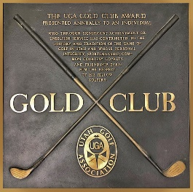
Utah Golf Association
Gold Club Award Nomination Form
Please return to UGA Executive Director

“The UGA Gold Club Award is presented annually to an individual who through significant achievement or unselfish service has contributed to the history and tradition of the game of golf in Utah, and whose personal integrity, sportsmanship, common courtesy, loyalty, and friendship earn him the love and respect of his fellow golfers.”

Past Recipients:
2018 - Reese Nielsen
2017 - Linda Olsen
2016 - Reed McGregor
2015 - Judy Allem
2014 - Randy Dodson
2013 - Dr. Pete Randall
2013 - Dave Terry
2012 - Tommy Sorensen
2011 - Kent McCurdy
2010 - Sherm Hatfield
2009 - Keith Hansen
2008 - Joe Watts
2007 - Parley Petersen
2006 - Doug Vilven
2005 - Tony Bermingham
2004 - Sonny Braun
2003 - Jerry Marks
2002 - Jeff Beaudry
2001 - Jeannie Goddard
2000 - Ernie Schneiter, Jr.
1999 - Toni Guest
1998 - Gordon Sperry
1997 - Scott Whittaker
1996 - Lynn Summerhays
1995 - Garey Chadwick
1994 - Larry Disera
1993 - Mark Passey
1992 - Marion Dunn
1991 - Jimmy Thompson
1990 - Karl Tucker
1989 - Steve Dunford
1988 - George Marks

Nominee Information
NOMINEE:
TELEPHONE:
E-MAIL:
NOMINATED BY:

HOW DOES THIS NOMINEE EMBODY THE MISSION OF THIS AWARD (see mission above):

